

**Touchstones**

***Netcards***

**Emotional Intelligence Netcards with Text**

All Directions HRJ

Anger HRJ

Children HRJ

Choose Wisely HRJ

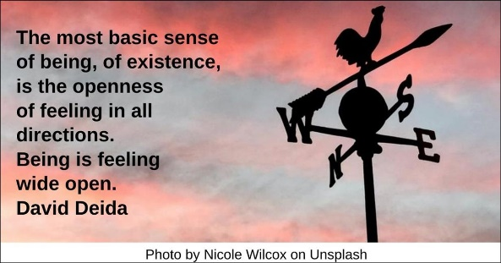

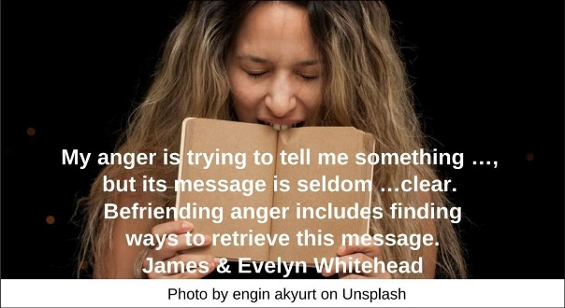

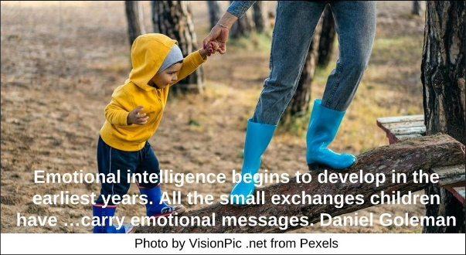

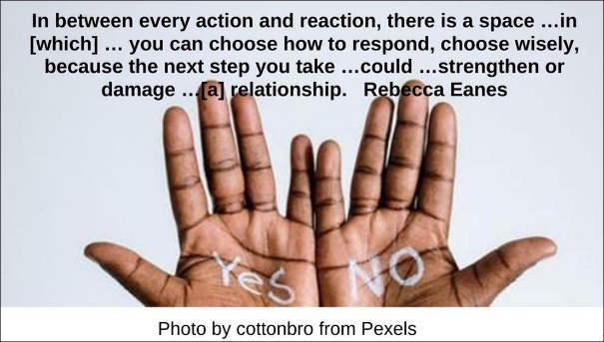

Compassion HRJ

Compassionate Heart HRJ

Despair HRJ

Empathy HRJ



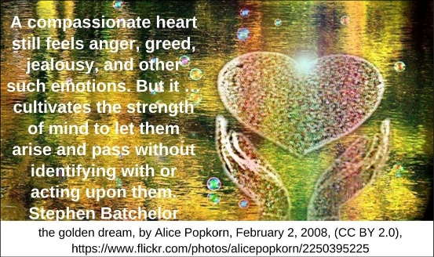

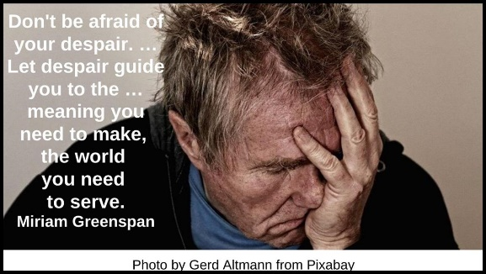

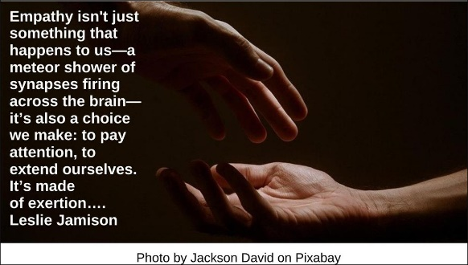

Energy HRJ

EQ HRJ

Everyday Practice HRJ

Generosity HRJ



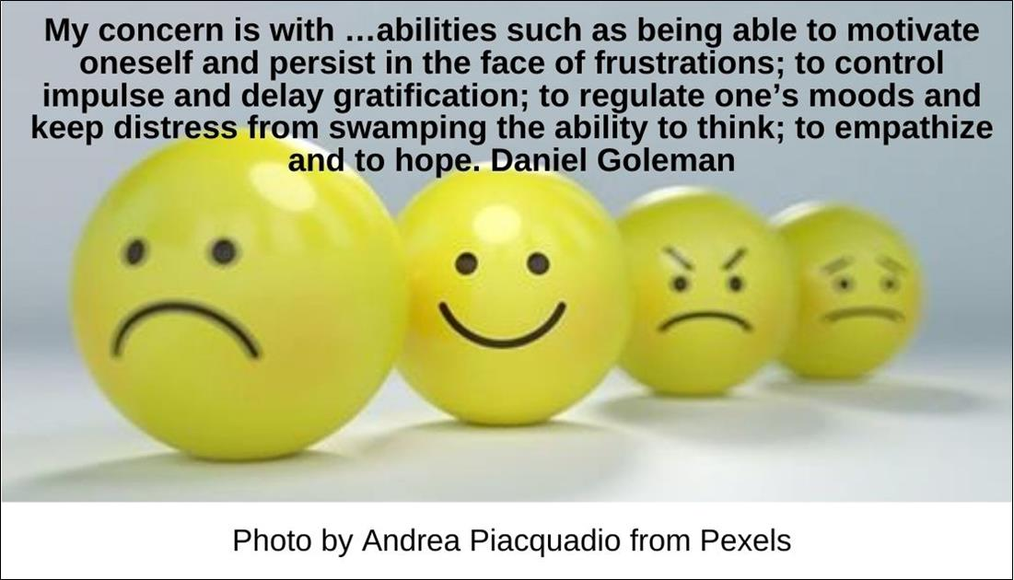

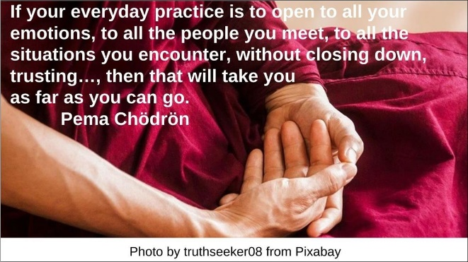

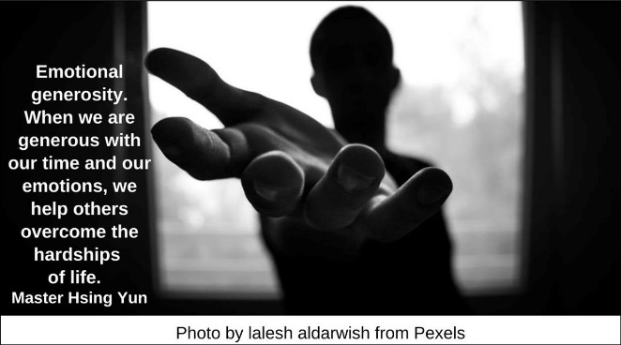

Heart and Mind HRJ

Imagination HRJ

Inquiry HRJ

Juggling HRJ

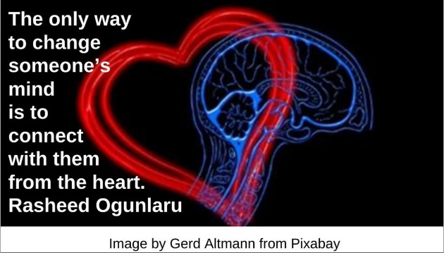

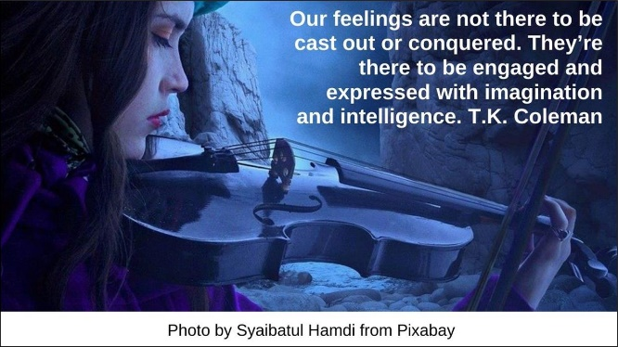

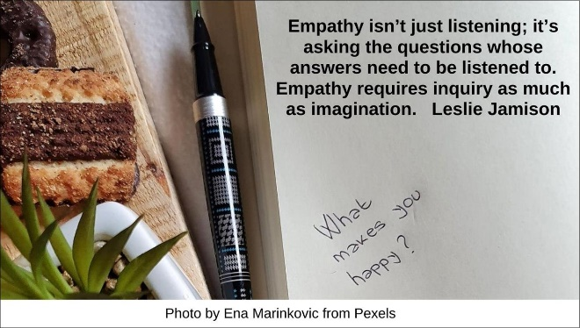

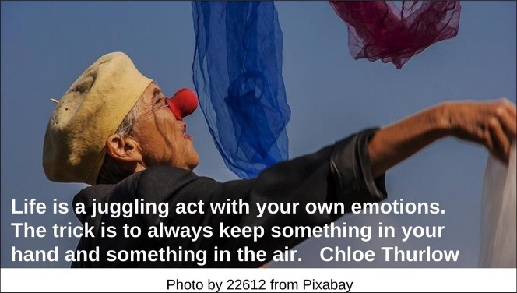

Mother HRJ

Move Out HRJ

Noise HRJ

Pallet HRJ

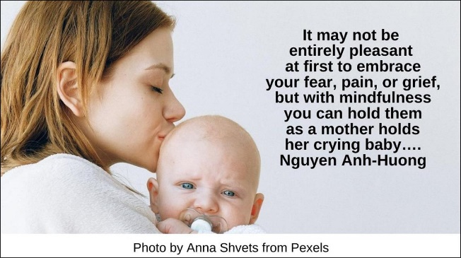

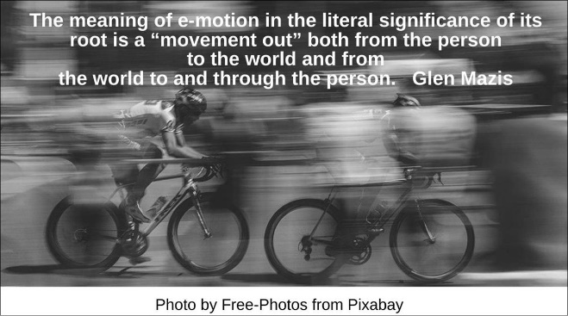

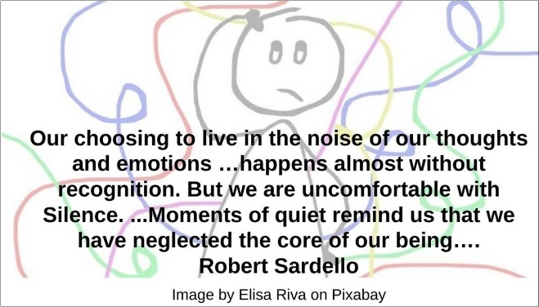

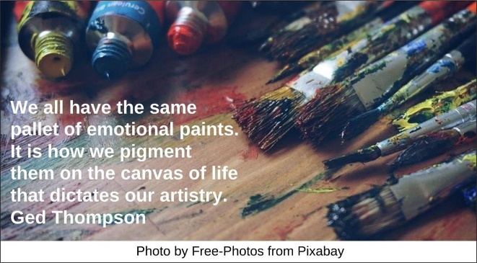

Perception HRJ

Practices HRJ

Respond HRJ

River HRJ

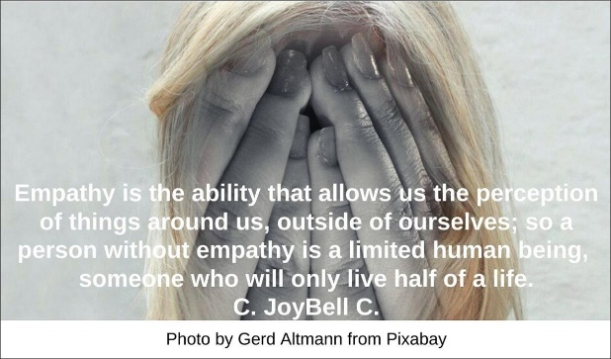

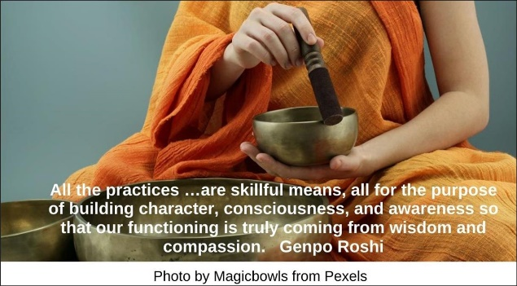

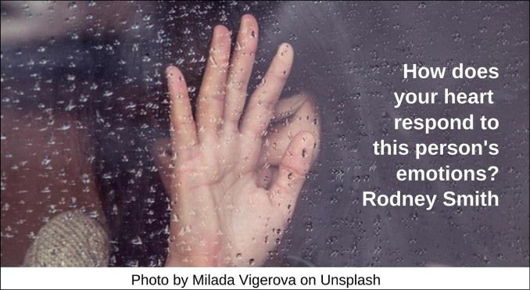

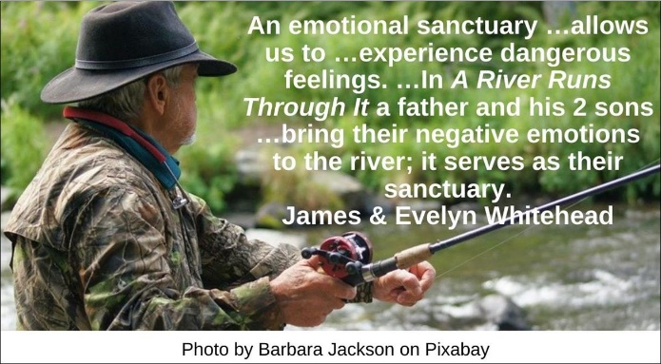

Self-Awareness HRJ

Soft HRJ

Spirituality HRJ

Stop HRJ

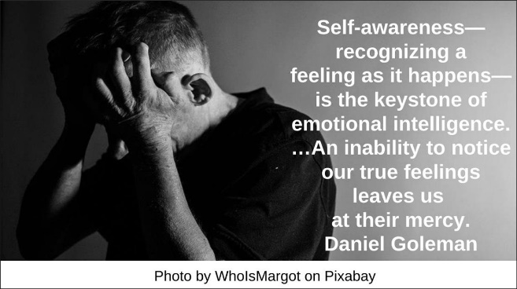

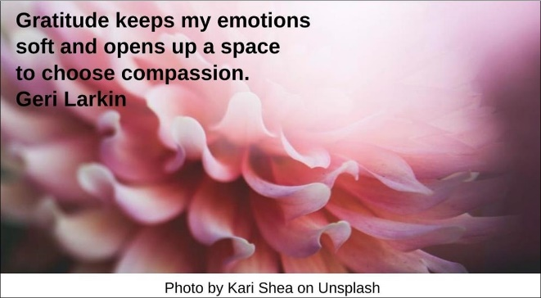

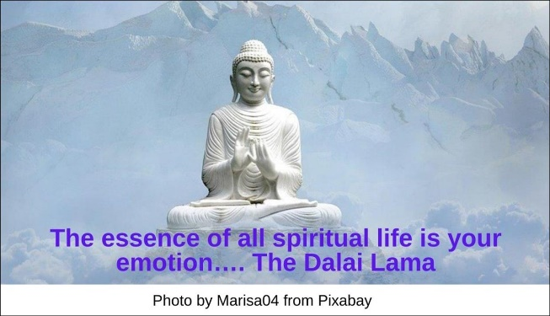

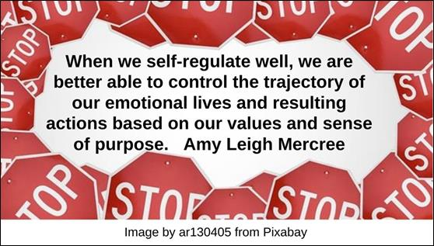

Truth HRJ

Two Minds HRJ

Waves HRJ

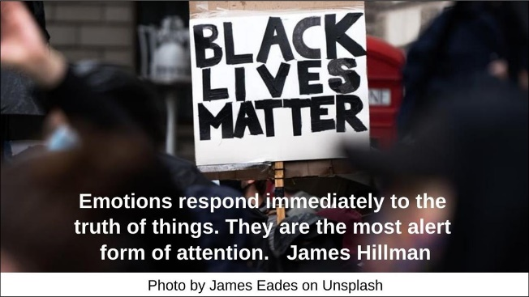

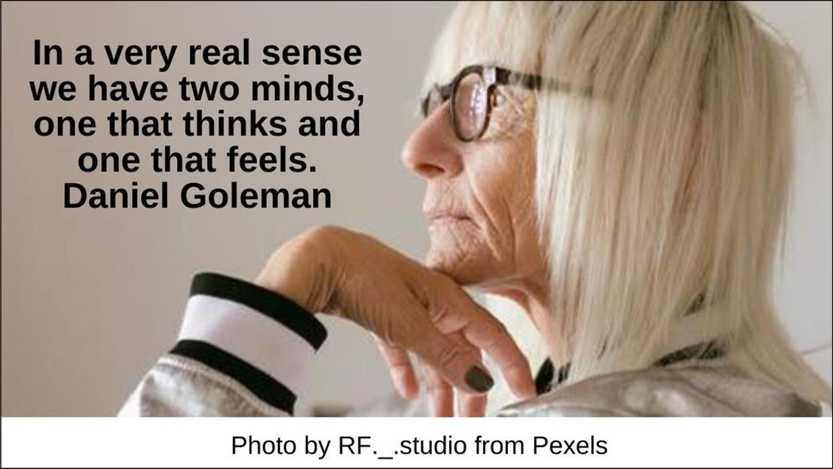

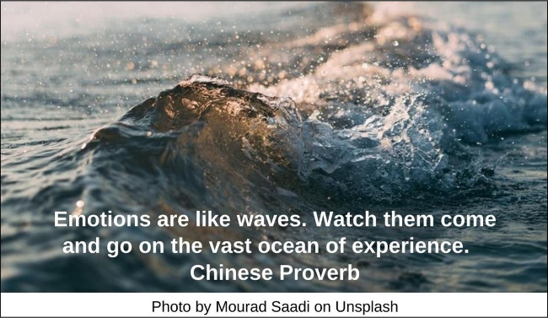

**Text of Quotes**

All Directions HRJ

The most basic sense of being, of existence, is the openness of feeling in all directions. Being is feeling wide open. David Deida

Anger HRJ

My anger is trying to tell me something …, but its message is seldom …clear. Befriending anger includes finding ways to retrieve this message. James & Evelyn Whitehead

Children HRJ

Emotional intelligence begins to develop in the earliest years. All the small exchanges children have …carry emotional messages. Daniel Goleman

Choose Wisely HRJ

Self-Regulation: In between every action and reaction, there is a space …in [which] … you can choose how to respond, choose wisely, because the next step you take …could …strengthen or damage …[a] relationship. Rebecca Eanes

Compassion HRJ

The passion of so many now is one of pain, of shock, of grieving, and of loss. Compassion allow you to feel those difficult emotions and the pain that lies beneath them. Gary Zukav

Compassionate Heart HRJ

A compassionate heart still feels anger, greed, jealousy, and other such emotions. But it …cultivates the strength of mind to let them arise and pass without identifying with or acting upon them. Stephen Batchelor

Despair HRJ

Don't be afraid of your despair. …Let despair guide you to the …meaning you need to make, the world you need to serve. Miriam Greenspan

Empathy HRJ

Empathy isn't just something that happens to us—a meteor shower of synapses firing across the brain—it’s also a choice we make: to pay attention, to extend ourselves. It’s made of exertion…. Leslie Jamison

Energy HRJ

Emotions are the richest source of energy we possess. Karla McLaren

EQ HRJ

My concern is with …abilities such as being able to motivate oneself and persist in the face of frustrations; to control impulse and delay gratification; to regulate one’s moods and keep distress from swamping the ability to think; to empathize and to hope. Daniel Goleman

Everyday Practice HRJ

If your everyday practice is to open to all your emotions, to all the people you meet, to all the situations you encounter, without closing down, trusting…, then that will take you as far as you can go. Pema Chödrön

Generosity HRJ

Emotional generosity. When we are generous with our time and our emotions, we help others overcome the hardships of life. Master Hsing Yun

Heart and Mind HRJ

The only way to change someone’s mind is to connect with them from the heart. Rasheed Ogunlaru

Imagination HRJ

Our feelings are not there to be cast out or conquered. They’re there to be engaged and expressed with imagination and intelligence. T.K. Coleman

Inquiry HRJ

Empathy isn’t just listening; it’s asking the questions whose answers need to be listened to. Empathy requires inquiry as much as imagination. Leslie Jamison

Juggling HRJ

Life is a juggling act with your own emotions. The trick is to always keep something in your hand and something in the air. Chloe Thurlow

Mother HRJ

It may not be entirely pleasant at first to embrace your fear, pain, or grief, but with mindfulness you can hold them as a mother holds her crying baby…. Nguyen Anh-Huong

Move Out HRJ

The meaning of e-motion in the literal significance of its root is a “movement out” both from the person to the world and from the world to and through the person. Glen Mazis

Noise HRJ

Our choosing to live in the noise of our thoughts and emotions …happens almost without recognition. But we are uncomfortable with Silence. …Moments of quiet remind us that we have neglected the core of our being…. Robert Sardello

Pallet HRJ

We all have the same pallet of emotional paints. It is how we pigment them on the canvas of life that dictates our artistry. Ged Thompson

Perception HRJ

Empathy is the ability that allows us the perception of things around us, outside of ourselves; so a person without empathy is a limited human being, someone who will only live half of a life. C. JoyBell C.

Practices HRJ

All the practices …are skillful means, all for the purpose of building character, consciousness, and awareness so that our functioning is truly coming from wisdom and compassion. Genpo Roshi

Respond HRJ

How does your heart respond to this person's emotions? Rodney Smith

River HRJ

An emotional sanctuary …allows us to …experience dangerous feelings. …In A River Runs Through It a father and his 2 sons …bring their negative emotions to the river; it serves as their sanctuary. James & Evelyn Whitehead

Self-Awareness HRJ

Self-awareness—recognizing a feeling as it happens—is the keystone of emotional intelligence. …An inability to notice our true feelings leaves us at their mercy. Daniel Goleman

Soft HRJ

Gratitude keeps my emotions soft and opens up a space to choose compassion. Geri Larkin

Spirituality HRJ

The essence of all spiritual life is your emotion…. The Dalai Lama

Stop HRJ

When we self-regulate well, we are better able to control the trajectory of our emotional lives and resulting actions based on our values and sense of purpose. Amy Leigh Mercree

Truth HRJ

Emotions respond immediately to the truth of things. They are the most alert form of attention. James Hillman

Two Minds HRJ

In a very real sense we have two minds, one that thinks and one that feels. Daniel Goleman

Waves HRJ

Emotions are like waves. Watch them come and go on the vast ocean of experience. Chinese Proverb